2014年江苏省高考英语试卷
第一部分听力（共两节，满分20分）
1．（1分）What does the woman want to do？
A．Find a place．B．Buy a map．C．Get an address．
2．（1分）What will the man do for the woman？
A．Repair her car．
B．Give her a ride．
C．Pick up her aunt．
3．（1分）Who might Mr．Peterson be？
A．A new professor．
B．A department head．
C．A company director．
4．（1分）What does the man think of the book？
A．Quite difficult．
B．Very interesting．
C．Too simple．
5．（1分）What are the speakers talking about？
A．Weather．B．Clothes．C．News．
6．（2分）听第6段材料，回答6、7题．
6．Why is Harry unwilling to join the woman？
A．He has a pain in his knee．
B．He wants to watch TV．
C．He is too lazy．
7．What will the woman probably do next？
A．Stay at home．
B．Take Harry to hospital．
C．Do some exercise．
7．（2分）听第7段材料，回答第8、9题．
8．When will the man be home from work？
A．At 5：45．
B．At 6：15．
C．At 6：50．
9．Where will the speakers go？
A．The Green House Cinema．
B．The New State Cinema．
C．The UME Cinema．
8．（3分）听第8段材料，回答第10至12题．
10．How will the speakers go to New York？
A．By air．
B．By taxi．
C．By bus．
11．Why are the speakers making the trip？
A．For business．
B．For shopping．
C．For hoilday．
12．What is the probable relationship between the speakers？
A．Driver and passenger．
B．Husband and wife．
C．Fellow workers．
9．（4分）（1）Where does this conversation probably take place？
A．In a restaurant．
B．In an office．
C．In a classroom．
（2）What does John do now？
A．He's a trainer．
B．He's a tour guide．
C．He's a college student．
（3）How much can a new person earn for the first year？
A．﹩10，500．
B．﹩12，000．
C．﹩15，000．
（4）How many people will the woman hire？
A．Four．
B．Three．
C．Two．
10．（4分）听第10段材料，回答第17至20题．
17．How long has the speaker lived in a big city？
A．One year． B．Ten years． C．Eighteen years．
18．What is the speaker's opinion on public transport？
A．It's comfortable． B．It's time﹣saving． C．It's cheap．
19．What is good about living in a small town？
A．It's safer． B．It's healthier． C．It's more convenient．
20．What kind of life does the speaker seem to like most？
A．Busy． B．Colourful． C．Quiet．
第二部分：英语知识运用（共两节，满分15分）第一节：单项填空（共15小题；每小题1分，满分15分）请阅读下面各题，从题中所给的A、B、C、D四个选项中，选出最佳选项，并在答题卡上将该项涂黑．

21．Lessons can be learned to face the future，________ history cannot be changed.
A．though B．as
C．since D．unless
22．The book has helped me greatly in my daily communication，especially at work ________ a good impression is a must.
A．which B．when
C．as D．where
23．—How much do you know about the Youth Olympic Games to be held in Nanjing?
—Well，the media ________ it in a variety of forms.
A．cover B．will cover
C．have covered D．covered
24．Tom always goes jogging in the morning and he usually does pushups too to stay ________.
A．in place B．in order
C．in shape D．in fashion
25．Top graduates from universities are ________ by major companies.
A．chased B．registered
C．offered D．compensated
26．—What a mess! You are always so lazy!
—I’m not to blame，mum.I am ________ you have made me.
A．how B．what
C．that D．who
27．She was put under house arrest two years ago but remained a powerful ________ in last year’s election.
A.symbol B．portrait
C．identity D．statue
28．The idea “happiness，”________，will not sit still for easy definition.
A．to be rigid B．to be sure
C．to be perfect D．to be fair
29．The lecture ________，a lively questionandanswer session followed.
A．being given B．having given
C．to be given D．having been given
30．—Dad，I don’t think Oliver the right sort of person for the job.
—I see.I’ll go right away and ________.
A．pay him back B．pay him off
C．put him away D．put him off

31．It was sad to me that they，so poor themselves，________ bring me food.
A．might B．would
C．should D．could
32．I can’t meet you on Sunday.I’ll be ________ occupied.
A．also B．just
C．nevertheless D．otherwise
33．Legend has it that the origin of the Dragon Boat Festival is to ________ the soul of Qu Yuan.
A．remember B．remind
C．recover D．recall
34．Good families are much to all their members，but ________ to none.
A．something B．anything
C．everything D．nothing
35．—________！ Somebody has left the lab door open.
—Don’t look at me.
A．Dear me B．Hi，there
C．Thank goodness D．Come on
第二节 完形填空(共20小题；每小题1分，满分20分)
请阅读下面短文，从短文后各题所给的A、B、C、D四个选项中，选出最佳选项。
Dale Carnegie rose from the unknown of a Missouri farm to international fame because he found a way to fill a universal human need.
It was a need that he first __36__ back in 1906 when young Dale was a junior at State Teachers College in Warrensburg.To get an __37__，he was struggling against many difficulties.His family was poor.His Dad couldn’t afford the __38__ at college，so Dale had to ride horseback 12 miles to attend classes.Study had to be done __39__ his farmwork routines.He withdrew from many school activities __40__ he didn’t have the time or the __41__.He had only one good suit.He tried __42__ the football team，but the coach turned him down for being too __43__.During this period Dale was slowly __44__ an inferiority complex(自卑感)，which his mother knew could __45__ him from achieving his real potential.She __46__ that Dale join the debating team，believing that__47__ in speaking could give him the confidence and recognition that he needed.
Dale took his mother’s advice，tried desperately and after several attempts __48__ made it.This proved to be a __49__ point in his life.Speaking before groups did help him gain the __50__ he needed.By the time Dale was a senior，he had won every top honor in __51__.Now other students were coming to him for coaching and they，__52__，were winning contests.
Out of this early struggle to __53__ his feelings of inferiority，Dale came to understand that the ability to __54__ an idea to an audience builds a person’s confidence.And，__55__ it，Dale knew he could do anything he wanted to do—and so could others.
36．A.admitted B．filled
C．supplied D．recognized
37．A.assignment B．education
C．advantage D．instruction
38．A.training B．board
C．teaching D．equipment
39．A.between B．during
C．over D．through
40．A.while B．when
C．because D．though
41．A.permits B．interest
C．talent D．clothes
42．A.on B．for
C．in D．with
43．A.light B．flexible
C．optimistic D．outgoing
44．A.gaining B．achieving
C．developing D．obtaining
45．A.prevent B．protect
C．save D．free
46．A.suggested B．demanded
C．required D．insisted
47．A.presence B．practice
C．patience D．potential
48．A.hopefully B．certainly
C．finally D．naturally
49．A.key B．breaking
C．basic D．turning
50．A.progress B．experience
C．competence D．confidence
51．A.horseriding B．football
C．speech D．farming
52．A.in return B．in brief
C．in turn D．in fact
53．A.convey B．overcome
C．understand D．build
54．A.express B．stress
C．contribute D．repeat
55．A.besides B．beyond
C．like D．with

第三部分 阅读理解(共15小题；每小题2分，满分30分)
请阅读下列短文，从短文后各题所给的A、B、C、D四个选项中，选出最佳选项。
A
Never before had a Kitchen so much of a History
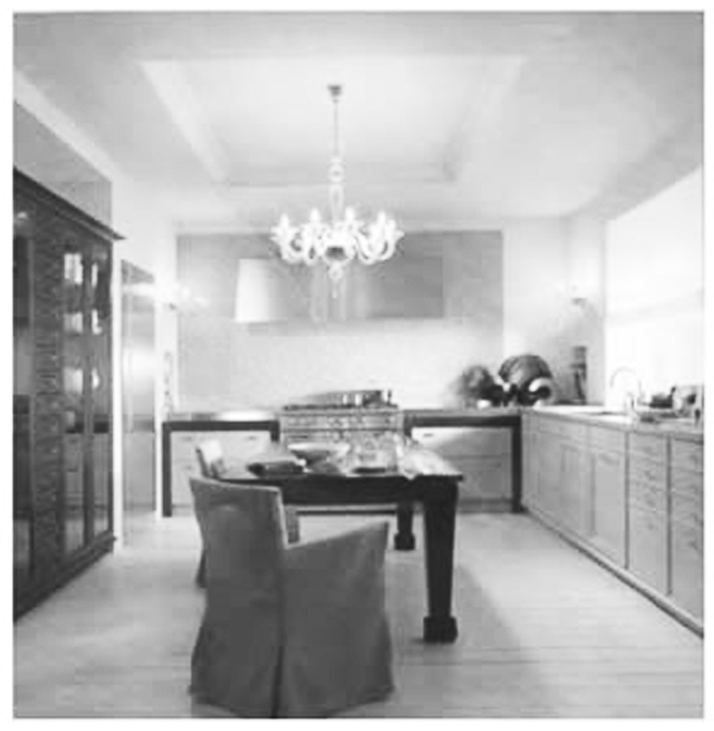
It tells of Freedom，Success，and of the Architecture of big American cities.Because that is where it started：in the second half of the 19th century!
Welcome to a new Era of Kitchen Interior Design
Back then，a Generation of successful American Entrepreneurs dreamt of a new style of Architecture to express their personal wealth.This dream was realized by young architects such as Daniel Burnham and Stanford White.They all had studied at the Ecole des BeauxArts in Paris.And they created a new style for Architecture and Interior Design，named after the famous French Art Institute：BeauxArts.
SieMatic BeauxArts Breaks and Creates
In fact it was not a new style at all，but a composition of styles from different periods and cultures.Many worldfamous structures such as the Chicago Art Institute and the Statue of Liberty account for it.But what does that have to do with your kitchen？Just as much as you want it to.Because in the same way that the anticonventional architects back then took the freedom to combine elements from different historical eras，today，you too can break the conventional rules of style and create something new：your own personal composition of your kitchen.For that，SieMatic BeauxArts offers unique opportunities：A broad range of seemingly conflicting features that you combine to a harmonious design of your own.You can choose from menu of various forms，appealing colors，and precious materials，to create an environment that is much more than just a kitchen：a reflection of your personality.
56．Why did the BeauxArts style attract American entrepreneurs?
A．It helped display their money status.
B．It was created by famous architects.
C．It was named after a famous institute.
D．It represented the 19th century urban culture.

57．What is unique of SieMatic BeauxArts?
A．Its designs are anticonventional.
B．Its designs come from famous structures.
C．Its customers can enjoy their own composition.
D．Its customers can choose from various new styles.
B
However wealthy we may be，we can never find enough hours in the day to do everything we want.Economics deals with this problem through the concept of opportunity cost，which simply refers to whether someone’s time or money could be better spent on something else.
Every hour of our time has a value.For every hour we work at one job we could quite easily be doing another，or be sleeping or watching a film.Each of these options has a different opportunity cost—namely，what they cost us in missed opportunities.
Say you intend to watch a football match but the tickets are expensive and it will take you a couple of hours to get to and from the stadium.Why not，you might reason，watch the game from home and use the leftover money and time to have dinner with friends？This—the alternative use of your cash and time—is the opportunity cost.
For economists，every decision is made by knowledge of what one must forgo—in terms of money and enjoyment—in order to take it up.By knowing precisely what you are receiving and what you are missing out on，you ought to be able to make betterinformed，more reasonable decisions.Consider that most famous economic rule of all：there’s no such thing as a free lunch.Even if someone offers to take you out to lunch for free，the time you will spend in the restaurant still costs you something in terms of forgone opportunities.
Some people find the idea of opportunity cost extremely discouraging：imagine spending your entire life calculating whether your time would be better spent elsewhere doing something more profitable or enjoyable.Yet，in a sense it’s human nature to do precisely that—we assess the advantages and disadvantages of decisions all the time.
In the business world，a popular phrase is “value for money.” People want their cash to go as far as possible.However，another is fast obtaining an advantage：“value for time.” The biggest restriction on our resources is the number of hours we can devote to something，so we look to maximize the return we get on our investment of time.By reading this passage you are giving over a bit of your time which could be spent doing other activities，such as sleeping and eating.In return，however，this passage will help you to think like an economist，closely considering the opportunity cost of each of your decisions.
58．According to the passage，the concept of “opportunity cost” is applied to ________.
A．making more money
B．taking more opportunities
C．reducing missed opportunities
D．weighing the choice of opportunities
59．The “leftover...time” in Paragraph 3 probably refers to the time ________.
A．spared for watching the match at home
B．taken to have dinner with friends
C．spent on the way to and from the match
D．saved from not going to watch the match
60．What are forgone opportunities?
A．Opportunities you forget in decisionmaking.
B．Opportunities you give up for better ones.
C．Opportunities you miss accidentally.
D．Opportunities you make up for.
C
Most damagingly，anger weakens a person’s ability to think clearly and keep control over his behaviour.The angry person loses objectivity in evaluating the emotional significance of the person or situation that arouses his anger.
Not everyone experiences anger in the same way；what angers one person may amuse another.The specific expression of anger also differs from person to person based on biological and cultural forces.In contemporary culture，physical expressions of anger are generally considered too socially harmful to be tolerated.We no longer regard duels(决斗) as an appropriate expression of anger resulting from one person’s awareness of insulting behaviour on the part of another.
Anger can be identified in the brain，where the electrical activity changes.Under most conditions EEG(脑电图) measures of electrical activity show balanced activity between the right and left prefrontal(额叶前部) areas.Behaviourally this corresponds to the general evenhanded disposition(意向) that most of us possess most of the time.But when we are angry the EEG of the right and left prefrontal areas aren’t balanced and，as a result of this，we’re likely to react.And our behavioural response to anger is different from our response to other emotions，whether positive or negative.
Most positive emotions are associated with approach behaviour：we move closer to people we like.Most negative emotions，in contrast，are associated with avoidance behaviour：we move away from people and things that we dislike or that make us anxious.But anger is an exception to this pattern.The angrier we are，the more likely we are to move towards the object of our anger.This corresponds to what psychologists refer to as offensive anger：the angry person moves closer in order to influence and control the person or situation causing his anger.This approachandconfront behaviour is accompanied by a leftward prefrontal asymmetry(不对称) of EEG activity.Interestingly，this asymmetry lessens if the angry person can experience empathy(同感) towards the individual who is bringing forth the angry response.In defensive anger，in contrast，the EEG asymmetry is directed to the right and the angry person feels helpless in the face of the angerinspiring situation.
61．The “duels” example in Paragraph 2 proves that the expression of anger ________.
A．usually has a biological basis
B．varies among people
C．is socially and culturally shaped
D．influences one’s thinking and evaluation
62．What changes can be found in an angry brain?
A．Balanced electrical activity can be spotted.
B．Unbalanced patterns are found in prefrontal areas.
C．Electrical activity corresponds to one’s behaviour.
D．Electrical activity agrees with one’s disposition.
63．Which of the following is typical of offensive anger?
A．Approaching the source of anger.
B．Trying to control what is disliked.
C．Moving away from what is disliked.
D．Feeling helpless in the face of anger.
64．What is the key message of the last paragraph?
A．How anger differs from other emotions.
B．How anger relates to other emotions.
C．Behavioural responses to anger.
D．Behavioural patterns of anger.
D
August 1990，Boston
Dear Maya Shaoming，
To me，June 6,1990 is a special day.My longawaited dream came true the minute your father cried，“A girl！” You are more than just a second child，more than just a girl to match our boy.You，little daughter，are the link to our female line，the legacy of another woman’s pain and sacrifice 31 years ago.
Let me tell you about your Chinese grandmother.Somewhere in Hong Kong，in the late fifties，a young waitress found herself pregnant(怀孕) by a cook，probably a coworker at her restaurant.She carried the baby to term，suffered to give it birth，and kept the little girl for the first three months of her life.I like to think that my mother—your grandmother—loved me and fought to raise me on her own，but that the daily struggle was too hard.Worn down by the demands of the new baby and perhaps the constant threat of starvation，she made the painful decision to give away her girl so that both of us might have a chance for a better life.
More likely，I was dropped at the orphanage(孤儿院)steps or somewhere else.I will probably never know the truth.Having a baby in her unmarried state would have brought shame on the family in China，so she probably kept my existence a secret.Once I was out of her life，it was as if I had never been born.And so you and your brother and I are the missing leaves on a family tree.
Do they ever wonder if we exist?
Before I was two，I was adopted by an Anglo couple.Fed three square meals a day，I grew like a wild weed and grasped all the opportunities they had to offer—books，music，education，church life and community activities.In a family of blueeyed blonds，though，I_stood_out_like_a_sore_thumb.Whether from jealousy or fear of someone who looked so different，my older brothers sometimes teased me about my unpleasing skin，or made fun of my clumsy walk.Moody and impatient，burdened by fears that none of us realized resulted from my early years of need，I was not an easy child to love.My mother and I conflicted countless times over the years，but gradually came to see one another as real human beings with faults and talents，and as women of strength in our own right.Lacking a mirror image in the mother who raised me，I had to seek my identity as a woman on my own.The Asian American community has helped me regain my double identity.as a woman on my own.The Asian American community has helped me regain my double identity.
But part of me will always be missing:my beginnings,my personal history,all the delicate details that give a person her origin.Nevertheless,someone gave me a lucky name “Siu Wai.” “Siu” means“little,” and “Wai” means “clever.” Therefore,my baby name was “Clever little one.” Who chose those words?Who cared enough to note my arrival in the world?
I lost my Chinese name for 18 years.It was Americanized for convenience to “Sue.” But like an illfitting coat,it made me uncomfortable.I hated the name.But even more,I hated being Chinese.It took many years to become proud of my Asian origin and work up the courage to take back my birthname.That,plus a little knowledge of classroom Cantonese,is all the Chinese culture I have to offer you.Not white,certainly,but not really Asian,I try to pave the way between the two worlds and bridge the gap for you.Your name,“Shaoming,” is very much like mine—“Shao” means “little.” And “ming” is “bright,” as in a shining sun or moon.Whose lives will you brighten,little Maya? Your past is more complete than mine,and each day I cradle you in your babyhood,generously giving you the loving care I lacked for my first two years.When I pat you,I comfort the lost baby inside me who still cries for her mother.
Sweet Maya,it doesn’t matter what you “become” later on.You have already fulfilled my wildest dreams.
I love you,
Mommy
65．Why is June 6,1990 a special day for Mommy?
A．Her dream of being a mother came true.
B．She found her origin from her Chinese mother.
C．She wrote the letter to her daughter.
D．Her female line was well linked.
66．How does Mommy feel about her being given away?
A．It is bitter and disappointing.
B．It is painful but understandable.
C．She feels sorry but sympathetic.
D．She feels hurt and angry.
67．What does “I stood out like a sore thumb” in Paragraph 5 mean?
A．I walked clumsily out of pains.
B．I was not easy to love due to jealousy.
C．I was impatient out of fear.
D．I looked different from others.
68．What can be inferred from Mommy’s Anglo family life?
A．She used to experience an identity crisis.
B．She fought against her American identity.
C．She forgot the pains of her early years.
D．She kept her love for Asia from childhood.
69．Why did Mommy name her daughter “Shaoming”？
A．To match her own birthname.
B．To brighten the lives of the family.
C．To identify her with Chinese origin.
D．To justify her pride in Chinese culture.
70．By “Your past is more complete than mine，”Mommy means ________.
A．her past was completed earlier than Shaoming’s
B．Shaoming has got motherly care and a sense of roots
C．her mother didn’t comfort her the way she did Shaoming
D．her past was spent brokenly，first in Asia，then in the US

第四部分 任务型阅读(共10小题；每小题1分，满分10分)
请阅读下面短文，并根据所读内容在文章后表格中的空格里填入一个最恰当的单词。
注意：每个空格只填一个单词。
The expression，"everybody's doing it，"is very much at the center of the concept of peer pressure．It is a strong influence of a group，especially of children，on members of that group to behave as everybody else does．It can be positive or negative．Most people experience it in some way during their lives．
People are social creatures by nature，and so it is hardly surprising that part of their self﹣respect comes from the approval of others．This instinct （天性） is why the approval of peers，or the fear of disapproval，is such a powerful force in many people's lives．It is the same instinct that drives people to dress one way at home and another way at work，or to answer"fine"when a stranger asks"how are you？"even if it is not necessarily true．There is a practical aspect to this：it helps society to function efficiently，and encourages a general level of self﹣discipline that simplifies day﹣to﹣day interaction．
For certain individuals，seeking social acceptance is so important that it becomes like an addiction； in order to satisfy the desire，they may go so far as to abandon their sense of right and wrong．Teens and young adults may feel forced to use drugs，or join gangs that encourage criminal behavior．Mature adults may sometimes feel pressured to cover up illegal activity at the company where they work，or end up in debt because they are unable to hold back the desire to buy a house or car that they can't afford in an effort to"keep up with the Joneses．"
However，peer pressure is not always negative．A student whose friends are good at academics may be urged to study harder and get good grades．Players on a sports team may feel driven to play harder in order to help the team win．This type of influence can also get a friend off drugs，or to help an adult take up a good habit or drop a bad one．Study groups and class projects are examples of positive peer groups that encourage people to better themselves．
Schools try to teach kids about the dangers of negative peer pressure．They teach kids to stand up and be themselves，and encourage them to politely decline to do things that they believe are wrong．Similarly，it can be helpful to encourage children to greet the beneficial influence of positive peer groups．
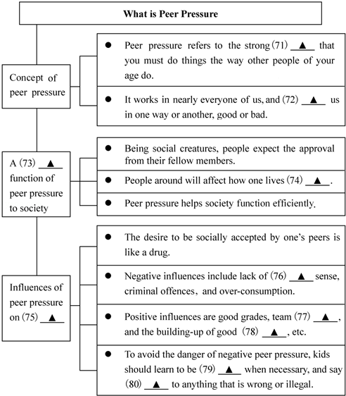
71． 72． 73． 74． 75． 76． 77． 78． 79． 80． ．
第五部分 书面表达(满分25分)
请阅读下面短文，并按照要求用英语写一篇150词左右的文章。
When we read newspapers，we often come across such English words as “AIDS” and “PK.” When we watch TV，we frequently hear words like “NBA” or “PM2.5.”When we speak，we automatically use words like “OUT” or “Byebye.” English words and expressions like these are getting popular.They have already become part of our daily language.And 239 English words have been included in the latest Dictionary of Contemporary Chinese.
The inclusion has started a heated discussion.A group of scholars signed a letter of complaint over the inclusion of these English words，which，they think，goes against Chinese language policies.They not only worry that Chinese is borrowing an increasing number of English words but are also concerned that the inclusion may hurt the dignity of the Chinese language.However，others are in favor of the inclusion because it is hard to say whether it will threaten the Chinese language.They believe the selection is mostly a result of their function and use in daily life.
写作内容
1．用约30个单词写出上文概要；
2．用约120个单词发表你的观点，内容包括：
(1)支持或反对汉语词典收录英语词汇；
(2)用2～3个理由或论据支撑你的观点。
写作要求
1．可以支持文中任一观点，但必须提供理由或论据；
2．阐述观点或提供论据时，不能直接引用原文语句；
3．作文中不能出现真实姓名和学校名称；
4．不必写标题。

